31st July 2011

COMMENDED FOR OUTSTANDING CONTRIBUTION TO SOCIETY
Emma Rose, Rutland’s ‘The Capable Manager’ was highly commended by her Alma Mater
The Open University in an inaugural alumni award.
The Open University Business School celebrates the exceptional achievements of its high calibre students annually. The awards, now in their 9th year, are held to commend some of the highest achieving students from the past academic year.

In 2012 two new alumni awards were introduced to recognise and celebrate some of the exceptional alumni within the community, and the success of all of these individuals was celebrated at an event held at The Open University campus in Milton Keynes on Friday 13 July.

‘Outstanding Contribution To Society’ is an award for those demonstrating the wider benefit of MBA, Diploma and Certificate learning and recognises achievements that take place outside of paid employment.

Emma Rose, aka The Capable Manager of Morcott in Rutland was appointed a UK Female Entrepreneurship Ambassador (UKFEA) in 2011. As part of a wider EU-funded ambassador network spanning 22 countries, sharing the message about the benefits of female entrepreneurship across Europe.

Emma was nominated for and was subsequently awarded ‘Highly Commended’ as runner up for ‘Outstanding Contribution To Society’ as a result of her work as a UKFEA and for her work with the Enterprising Women network, providing practical and strategic advice on digital marketing for businesses, as well as generally being a source of inspiration for businesswomen by encouraging them to shed negative attitudes.

‘…truly inspirational and speaks from the heart with courage and conviction. I can see why she was chosen to be a UK Female Entrepreneurship Ambassador.’ Sue Clarke, Interim Executive Lead for Children and Families, Central Surrey Health

The Open University reported that ‘Emma spoke eloquently and movingly as she accepted her award, articulating the impact studying for and achieving her MBA has had on her as an individual, a mother and a business woman.’ At the end of her acceptance, Emma quoted an unusual source to the room of academics to illustrate concepts of her own gratitude for support received, as well as the need to continue being supportive of others:

'In the words of Bill and Ted, be excellent to each other – you never know quite where someone will end up’. Emma Rose
Emma has taken the call from the EU SME Week 2011 for Women Entrepreneurship: learning, role models, and mentors; seriously. In 2012 she became a University Lecturer at The University of Northampton’s Business School teaching Management, Business, and Employability to the next generation of leaders.

The latter half of this year also sees Emma expanding in to an exciting role working for Rutland-based film director Bill Clark at Origami Films. Emma is an Assistant Producer for the film, a substantial project to be made in Rutland in 2012. ‘Starfish’ has been described as the British ‘Diving Bell and the Butterfly’ and is targeting a festival audience as well as attracting the attention of a high calibre cast.
– Ends –

Notes for editors:
- www.thecapablemanager.co.uk
- www.enterprising-women.org
- http://www.ukenterpriseambassadors.com/show.php?page=195
- http://ec.europa.eu/enterprise/initiatives/sme-week/
- http://www8.open.ac.uk/business-school/alumni/news-and-events/alumni-awards
- http://origamifilms.com/features.html
For more information please contact:
Emma Rose – The Capable Manager
Mobile: 07771 533 110
Desk: 0845 428 1990
Email: emma@thecapablemanager.co.uk

Photos follow:
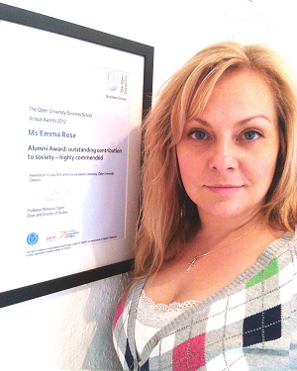
Photo 1 - Emma Rose with her award July 2012
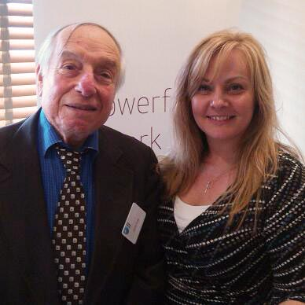
Photo 2 - Emma Rose with internationally acclaimed business author Derek S Pugh

